The Last Magician

# Characters introduction

## Liam

Role: The Boy Magician  
Affiliation: The Mountain Village  
Background: Liam is a curious and determined young boy from a remote mountain village. Despite his humble beginnings, he possesses a natural affinity for magic and an insatiable thirst for knowledge.

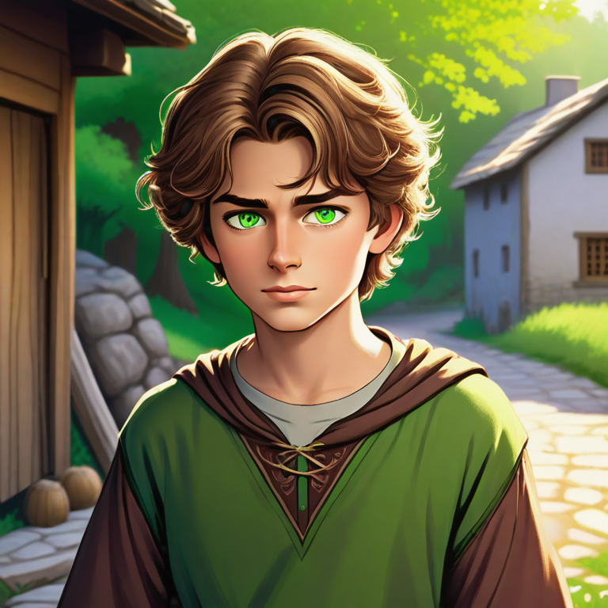

## Zarina

Role: Mentor  
Affiliation: The Ancient Order of Mages  
Background: Zarina is a centuries-old sorceress and the last surviving member of the Ancient Order of Mages. She senses Liam's potential and guides him in mastering his powers.

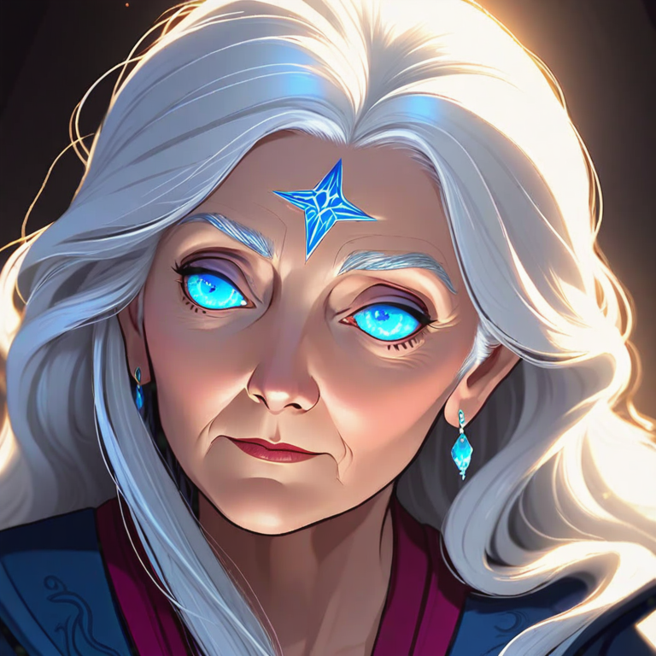

## Zythor

Role: Nemesis  
Affiliation: The Alien Invaders  
Background: Zythor is the merciless overlord of the alien invasion force. He seeks to conquer Earth and harness its resources for his empire's gain.

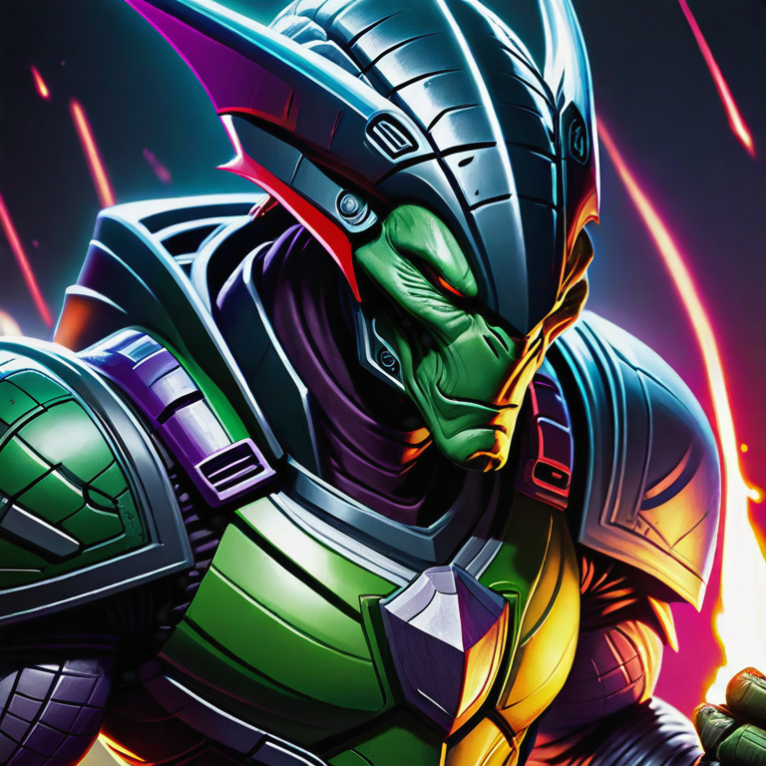

## Mira

Role: Childhood Friend  
Affiliation: The Mountain Village  
Background: Mira is Liam's best friend from the village. She stands by his side, providing unwavering support and loyalty as he embarks on his magical journey.

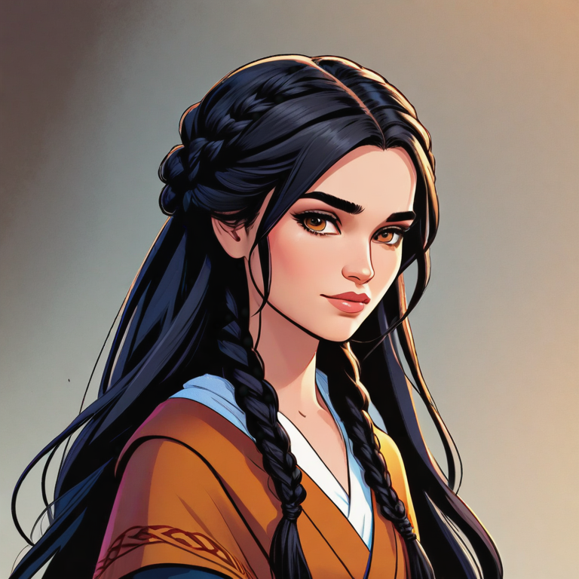

# The Ancient Tome

In the quaint mountain village of Evergreen, nestled deep within the ancient forest, lived a young boy named Liam. With an insatiable curiosity and a thirst for adventure, he often wandered the winding trails that snaked through the towering pines, seeking out the secrets hidden beneath the canopy of evergreen boughs. On one such excursion, his keen eyes spotted a peculiar, moss-covered stone protruding from the earth in a secluded glade. As he brushed away the undergrowth, Liam's breath caught in his throat - for there, half-buried in the soil, lay an ornate tome bound in cracked leather and adorned with arcane symbols that seemed to pulse with an otherworldly energy.

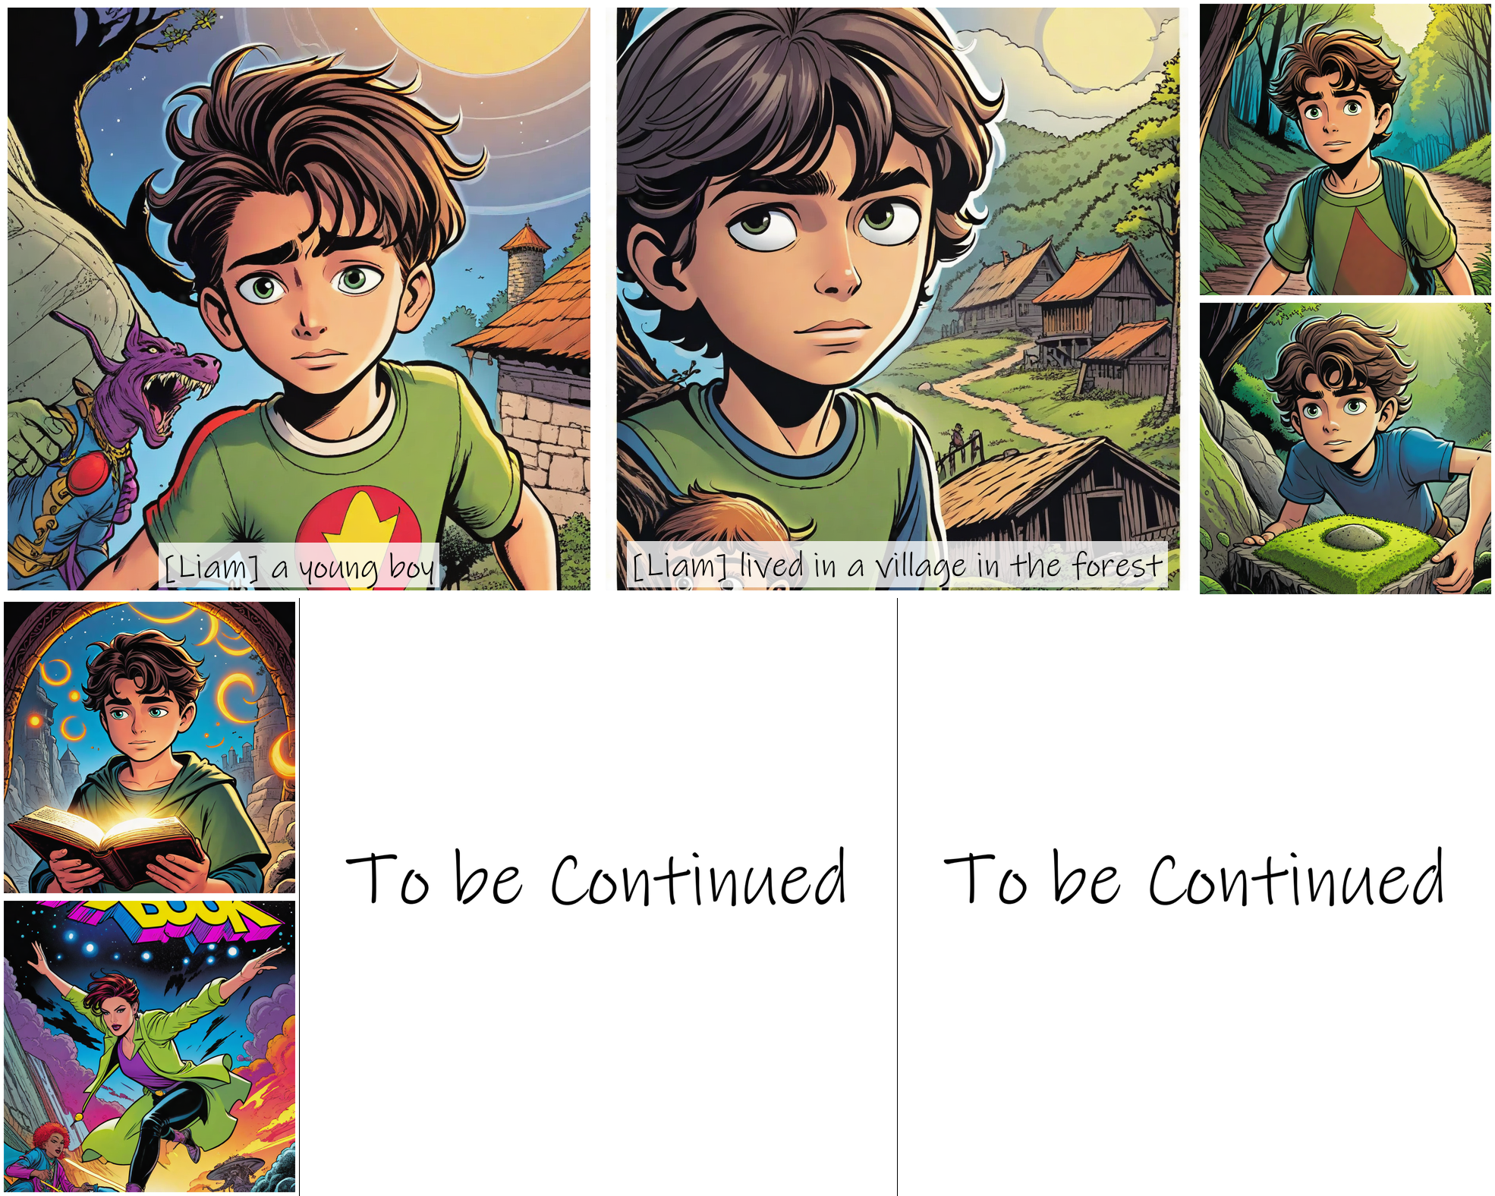

Trembling with excitement and a touch of trepidation, Liam pried the ancient book from its resting place and carefully opened its weathered pages. His eyes widened as he beheld the intricate illustrations and indecipherable text, seemingly written in a language long forgotten. Though he could not comprehend the words, a strange, tingling sensation coursed through his veins, as if the very magic contained within the tome resonated with his soul. In that moment, Liam felt a stirring deep within, a premonition that his life was about to change forever. From that day forth, he kept the book hidden, studying its mysteries in secret and practicing the hand gestures and incantations depicted, his natural talent for the mystic arts blossoming with each passing day, fueled by a newfound sense of purpose and destiny.

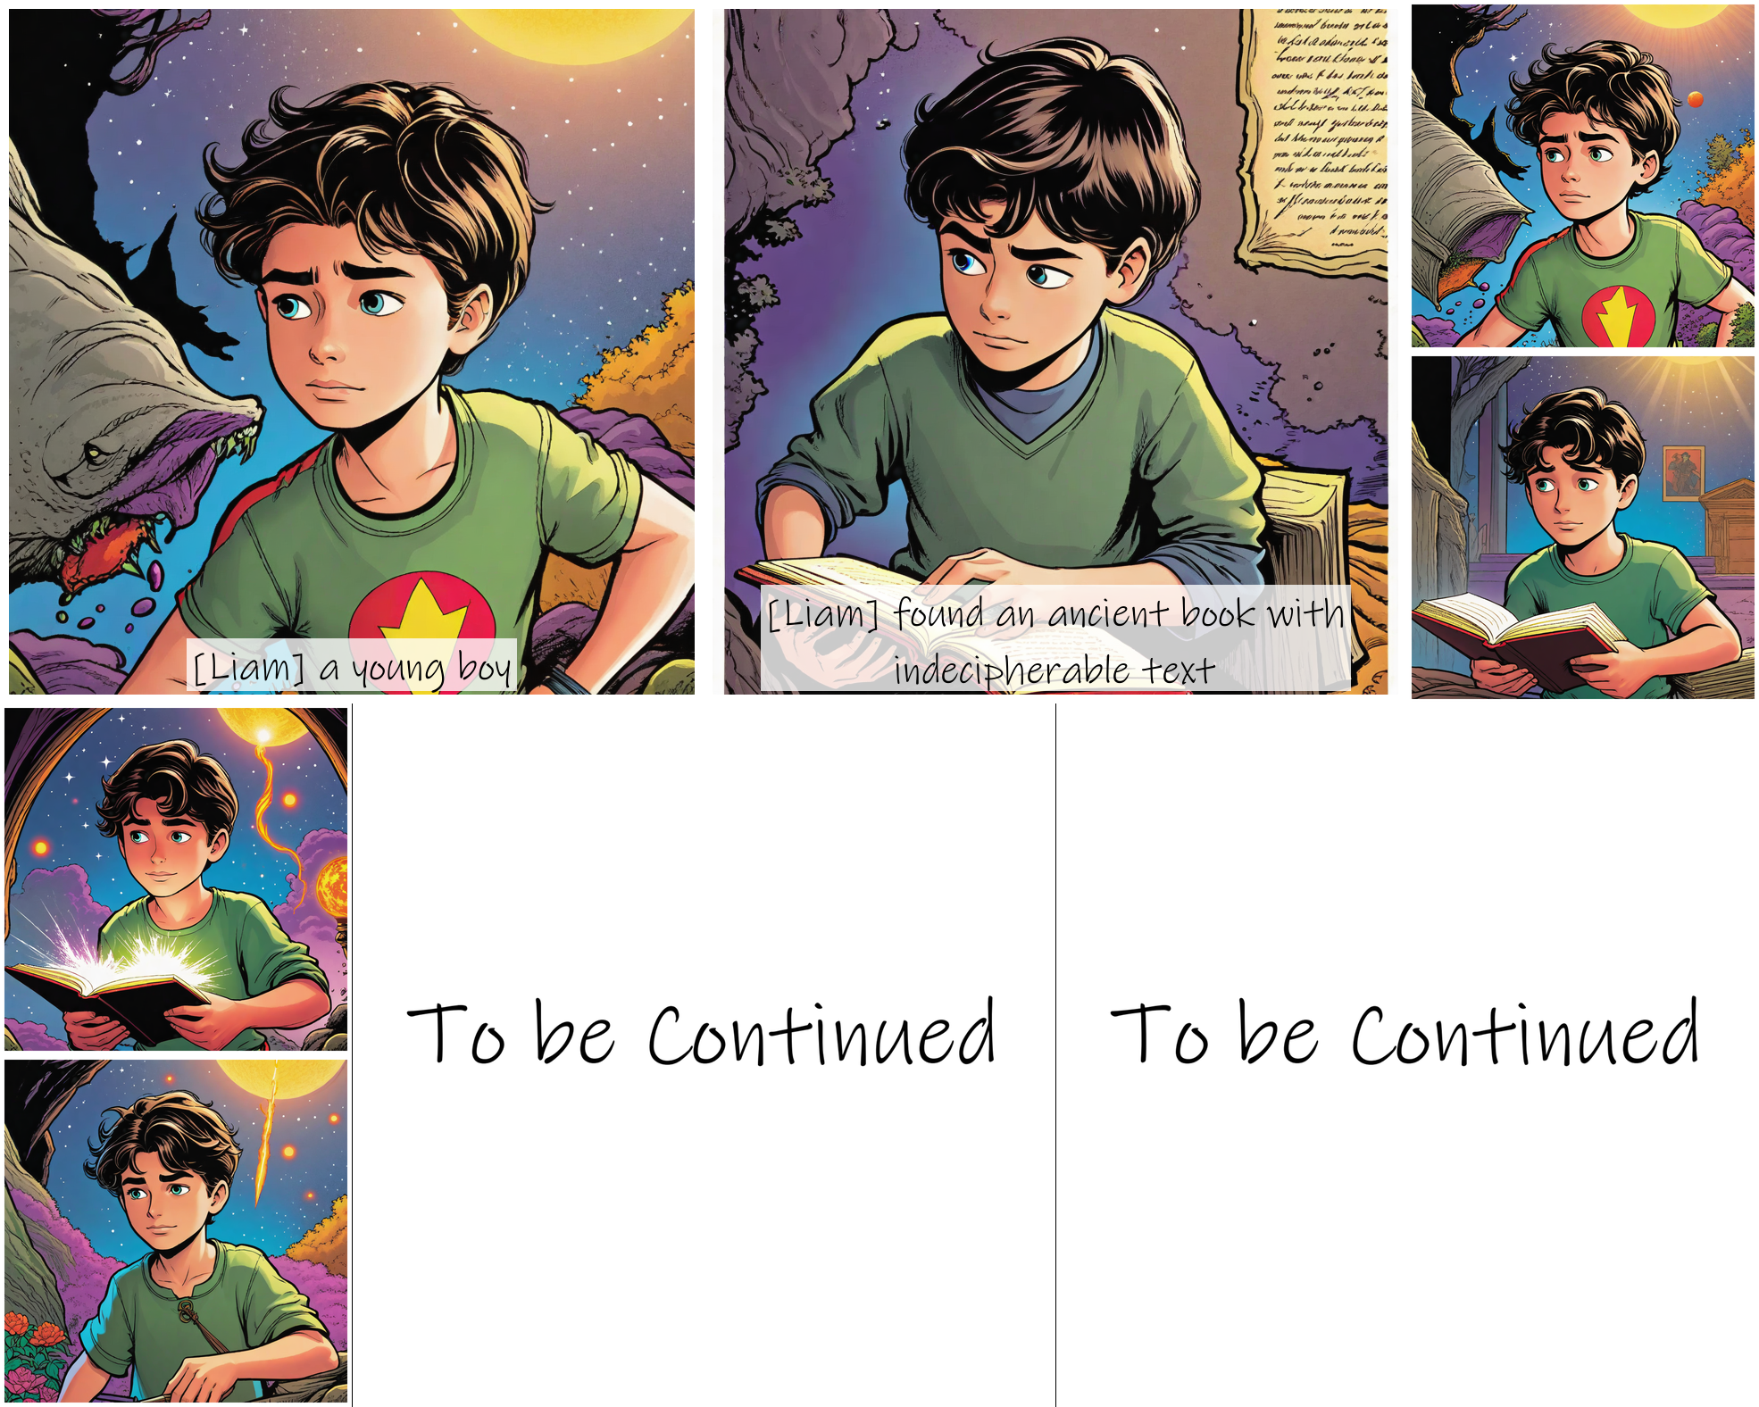

# Zarina's Guidance

Within the crumbling tower's ancient walls, Zarina pored over tomes and scrolls, seeking any clues that might shed light on the disturbance she had sensed. Her eyes, though weary from centuries of vigil, burned with determination. The fate of the world could very well rest upon her shoulders, and she knew she must act swiftly.

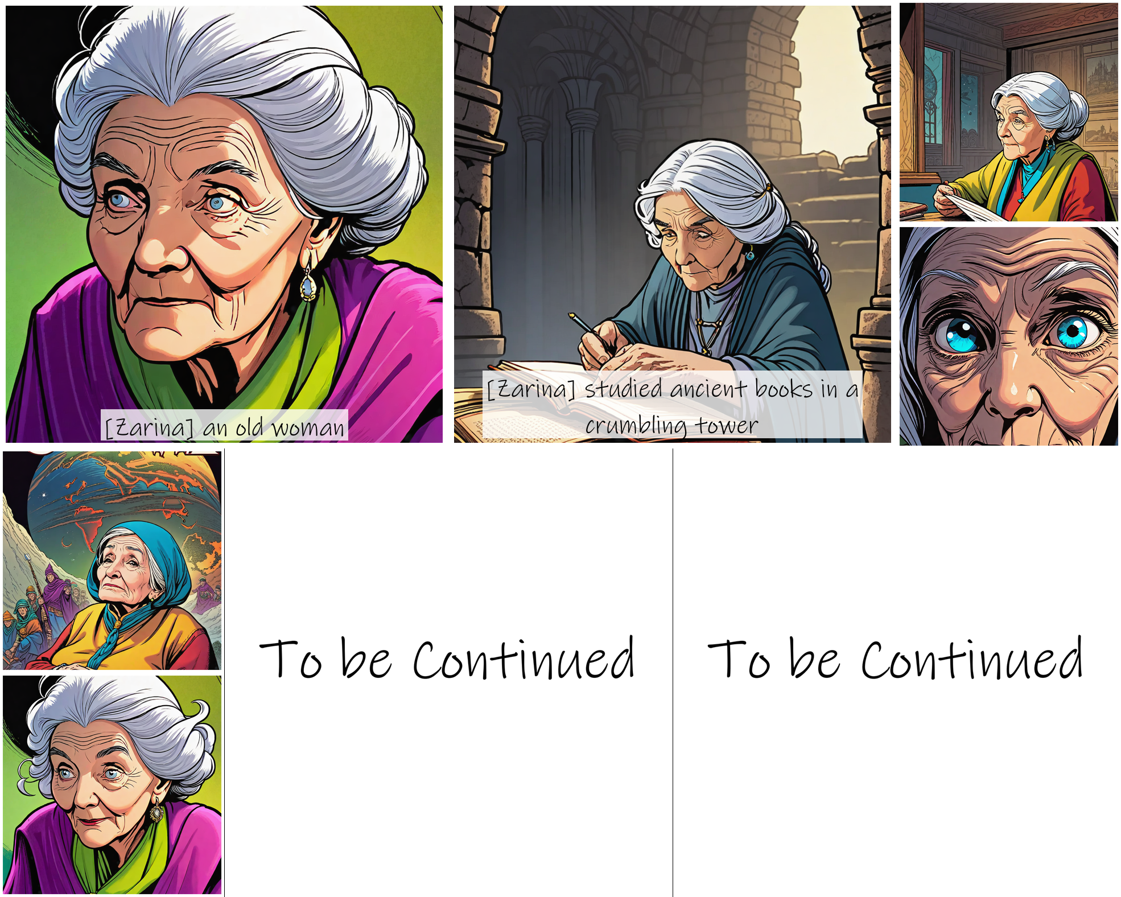

Under the veil of night, Zarina made her way to the mountain village, her footsteps leaving no trace upon the forest floor. There, she found Liam, the young boy whose awakening powers had stirred the ether. 'Greetings, young one,' she said, her voice carrying the weight of ages. 'I am Zarina, the last of the Ancient Order. The tome you have discovered holds secrets that must be mastered, for a great darkness looms on the horizon.'

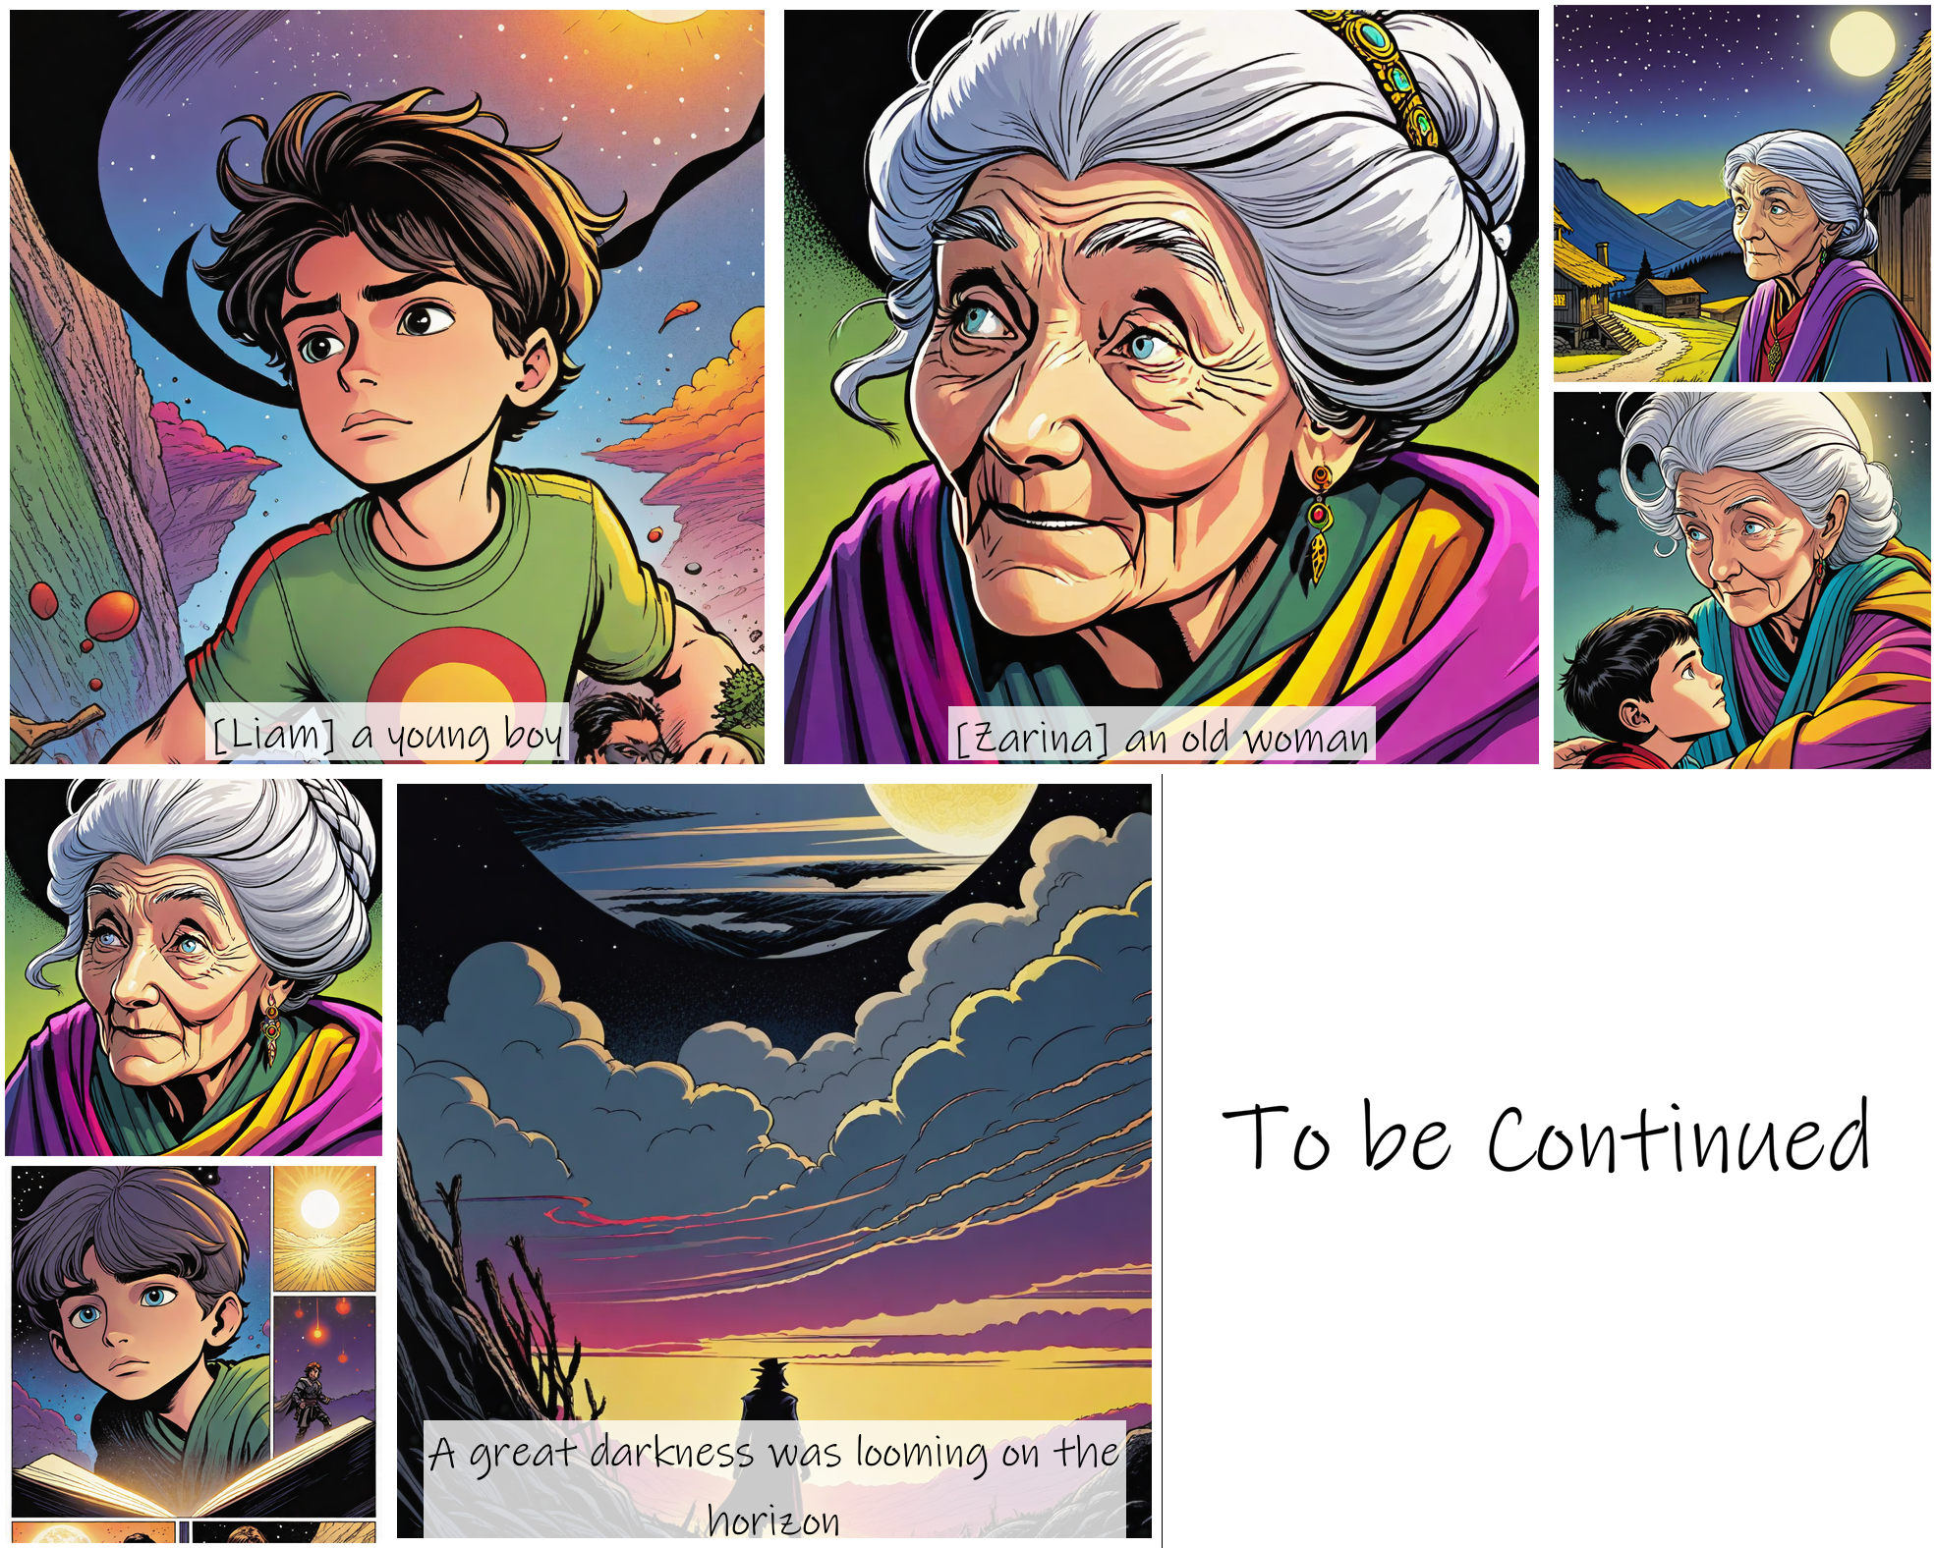

# The Alien Invasion

The skies above the mountain village darkened as a massive alien mothership descended from the clouds, its sleek metallic hull gleaming in the sunlight. Liam and Zarina watched in horror as smaller fighter ships poured out, raining down energy blasts that decimated the nearby towns and military bases. The ground trembled beneath their feet as explosions rocked the landscape. 'Zythor's forces have arrived,' Zarina said grimly, her eyes narrowing. 'Their technology is far beyond anything our world has ever seen. We must act quickly if we are to save Earth.'

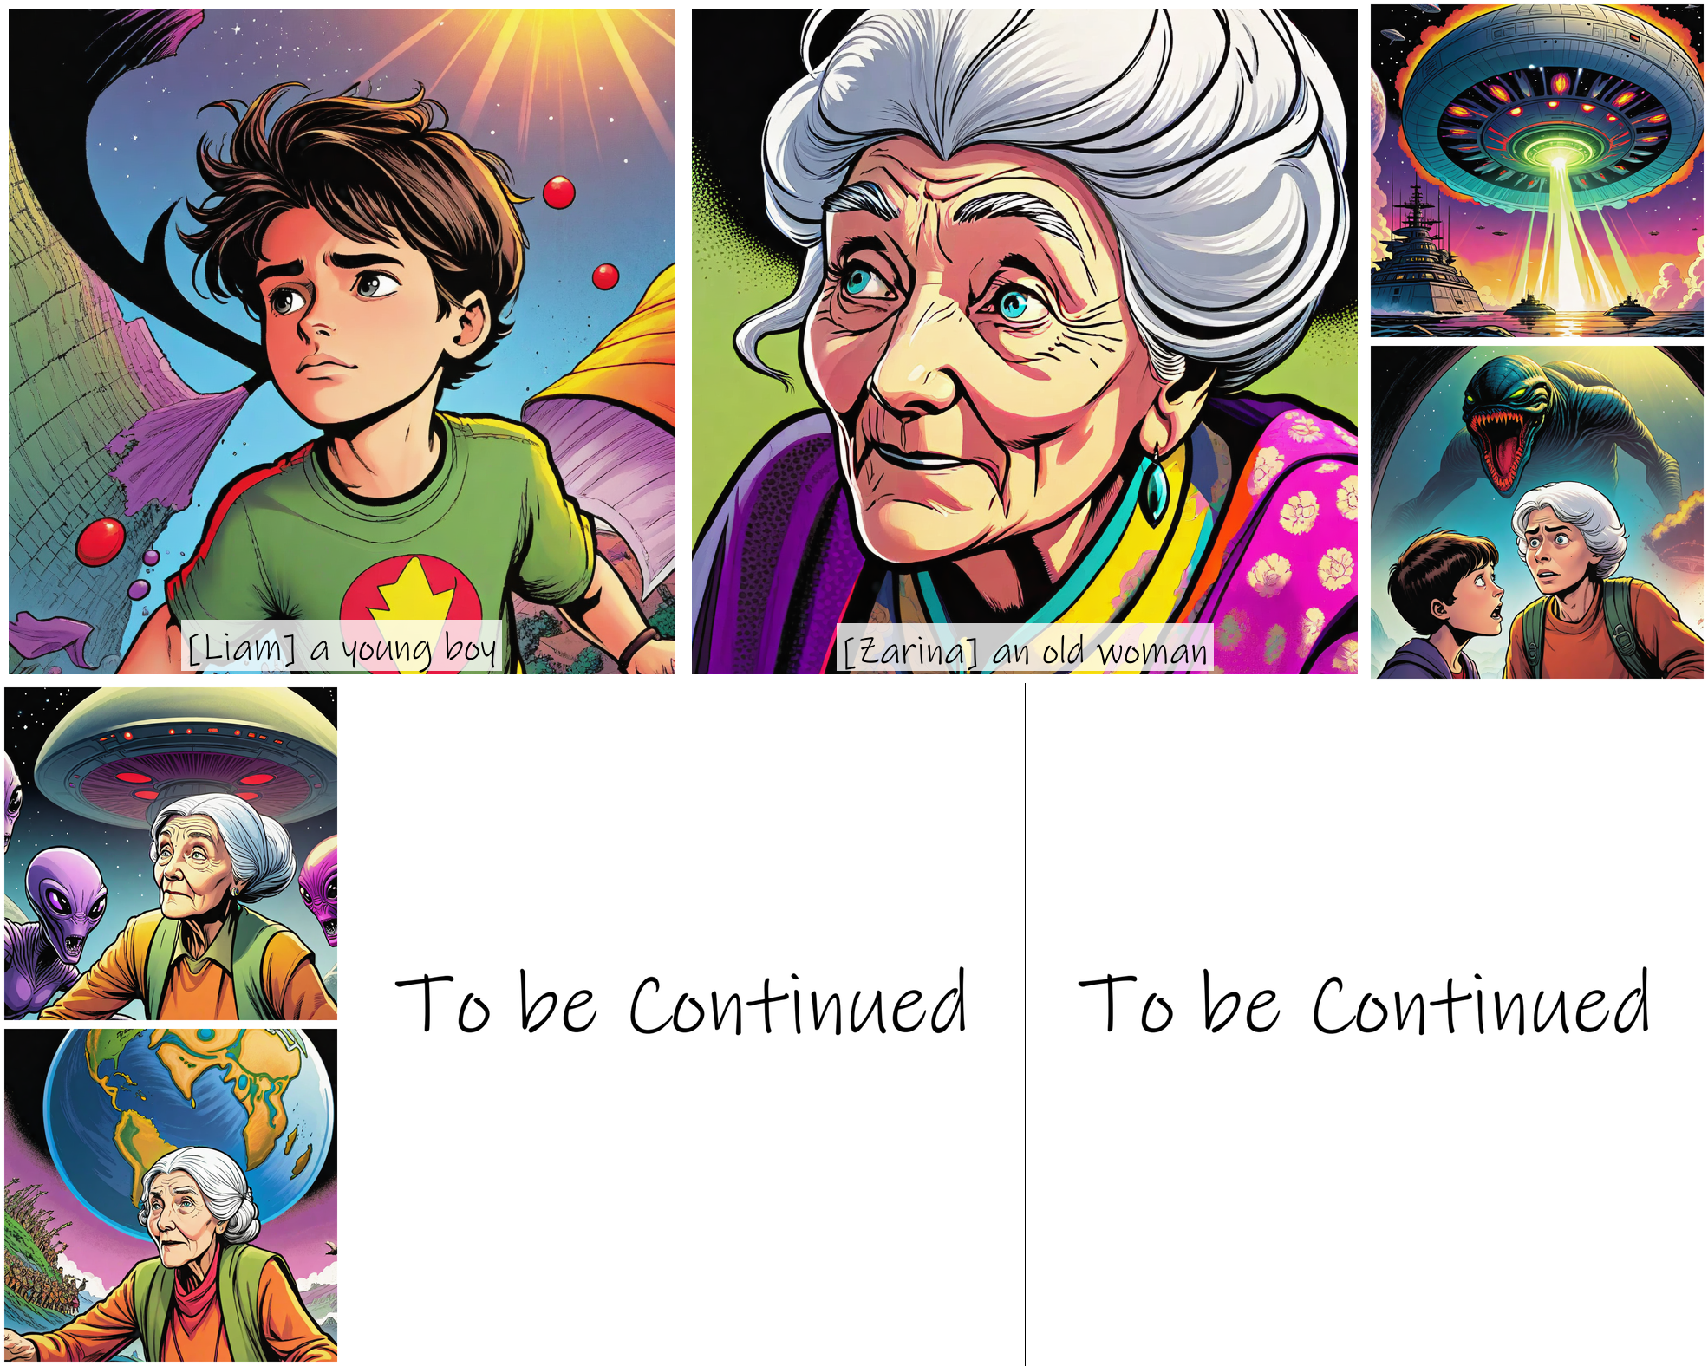

The world's armies mobilized, scrambling jets and tanks in a desperate attempt to repel the alien invaders. But their missiles and bullets merely glanced off the aliens' deflector shields, while their cities crumbled under the onslaught of plasma cannons and disintegration rays. Mira watched in horror from the village as towering war machines stomped through the ruins, their tentacled aliens soldiers rounding up survivors. 'We're no match for them,' she whispered, tears streaming down her face. Liam clenched his fists, his eyes blazing with determination. 'Then it's up to me,' he said, turning to Zarina. 'I'm ready.'

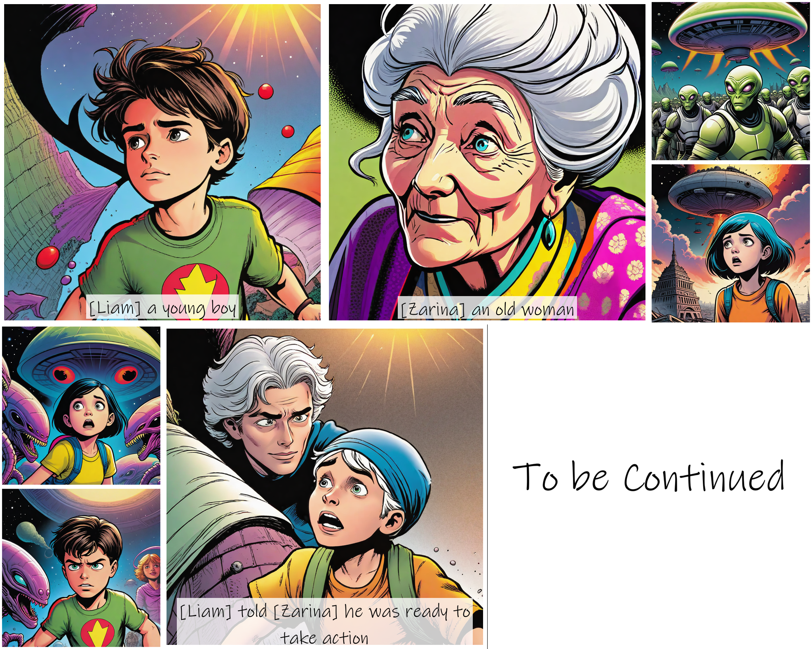

# The Boy Magician Rises

Liam stood tall, his eyes blazing with determination as he faced the towering form of Zythor. The alien overlord sneered, his reptilian features twisting in contempt. 'A mere child dares to challenge the might of the Zyktarian Empire?' Zythor boomed, his voice shaking the very ground beneath their feet.

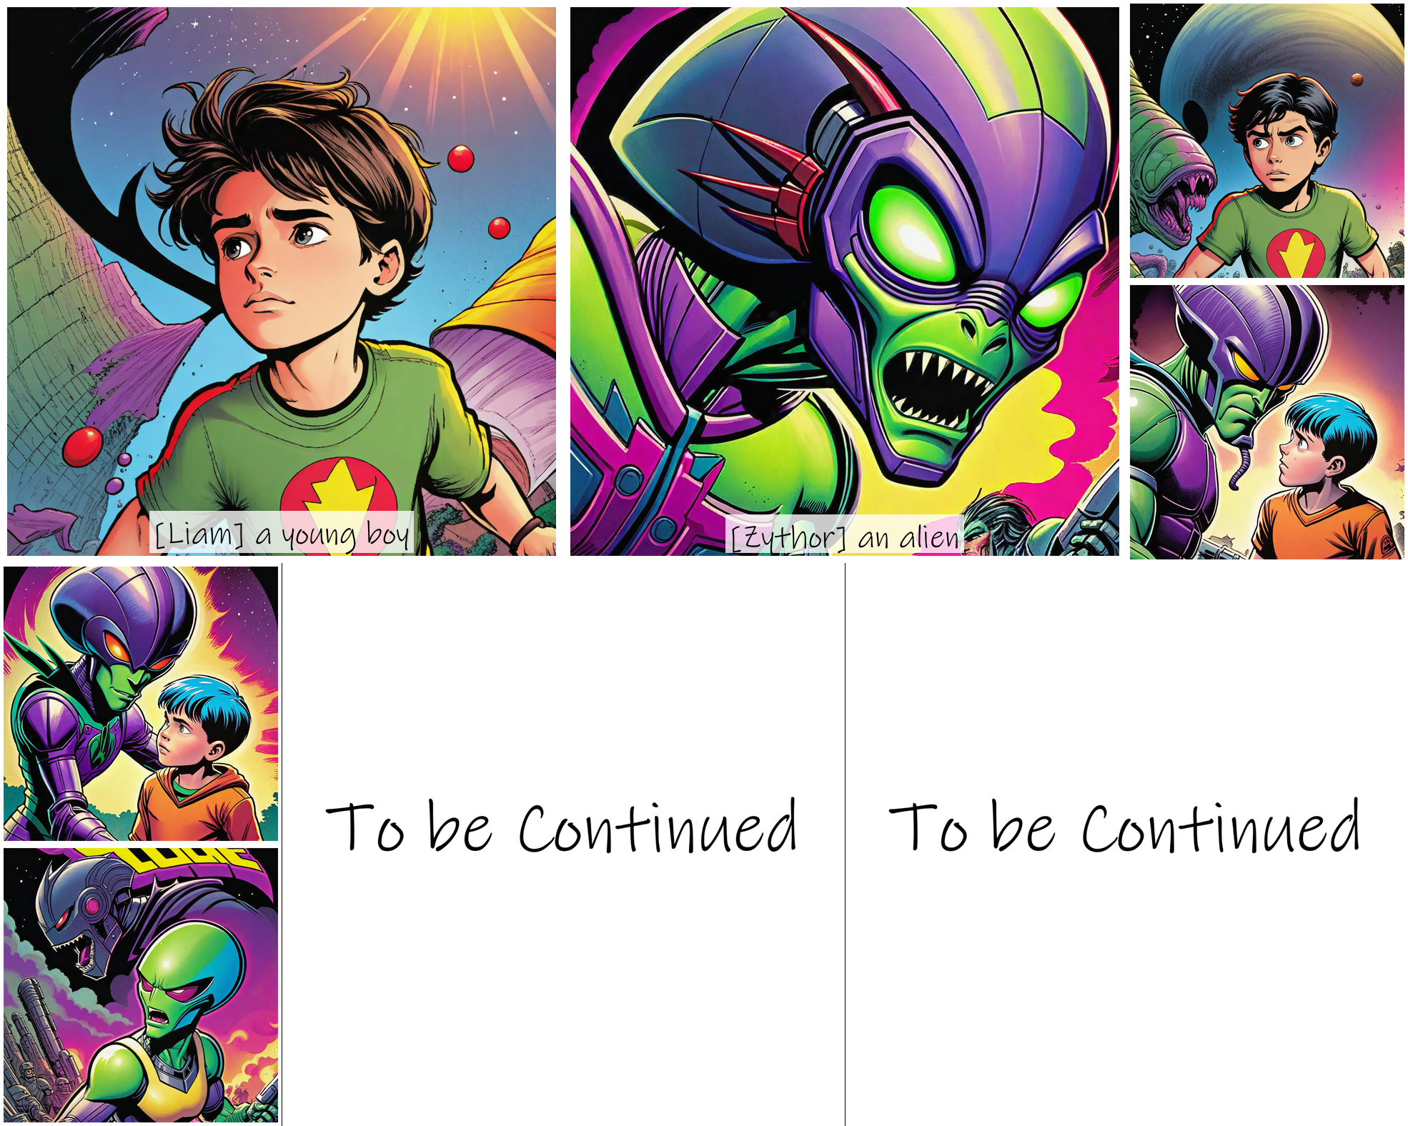

Beside Liam, Mira gripped his hand tightly, her unwavering loyalty giving him strength. With a wave of his hand, Liam conjured a shimmering barrier around them, deflecting the searing energy blasts from Zythor's soldiers. 'Your technology is no match for the ancient magic I wield,' Liam declared, his voice resonating with power. Weaving intricate patterns in the air, he summoned a swirling vortex of arcane energy, engulfing Zythor's forces in a maelstrom of mystical fury.

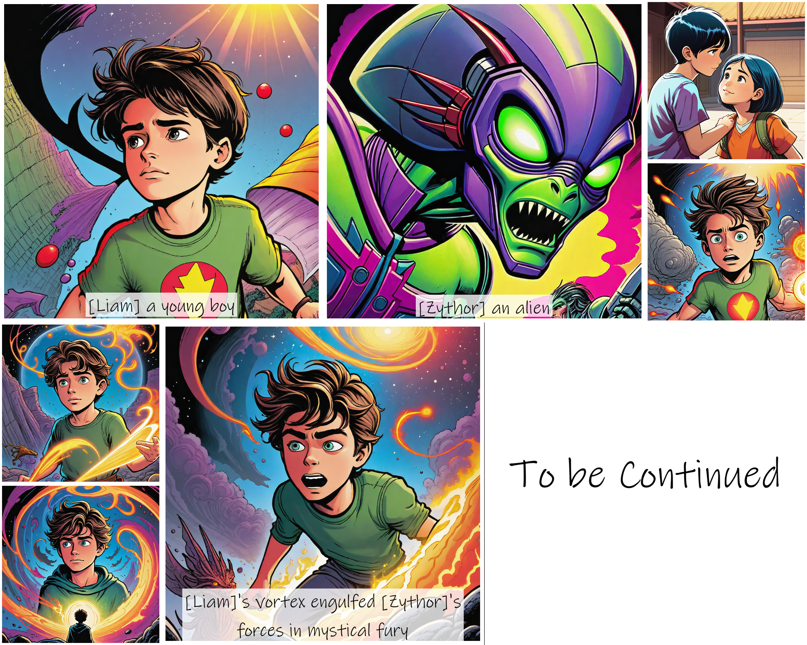

# The Final Battle

The sky burned crimson as the alien warships unleashed their fury upon the Earth, their energy beams slicing through buildings and scorching the ground. Liam stood tall amidst the chaos, his eyes blazing with determination, the ancient tome's incantations echoing in his mind. Beside him, Zarina's face was etched with concern, while Mira clung to his arm, her eyes wide with fear.

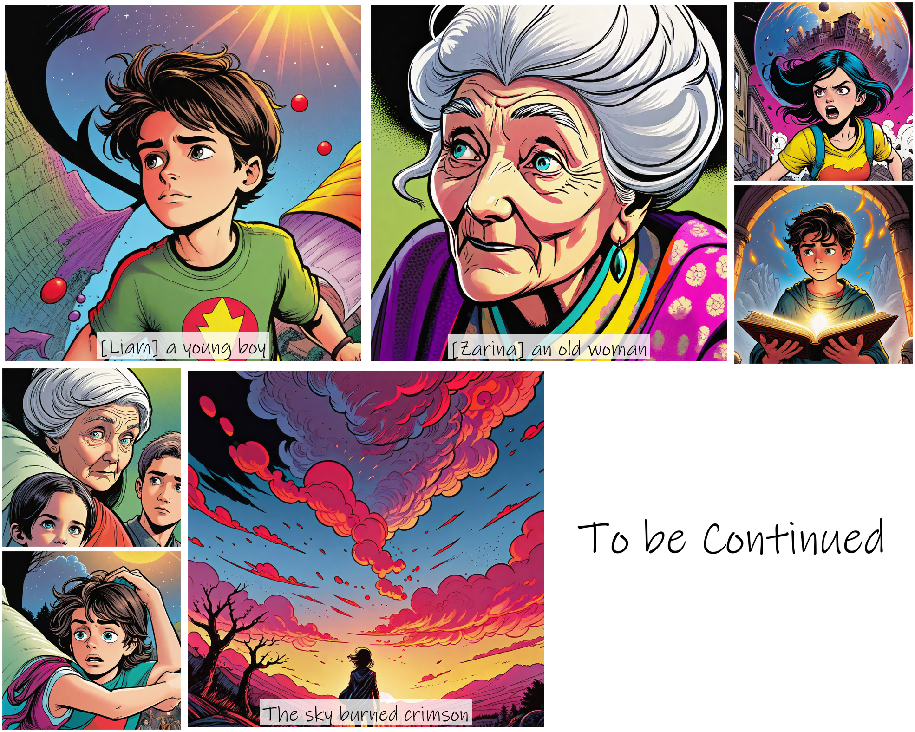

A deafening roar shook the air as Zythor's colossal form emerged from the mothership, his reptilian features twisting into a sneer. 'So, the boy magician dares to challenge me?' the alien overlord bellowed, his voice dripping with disdain. 'Your pitiful magic is no match for the might of the Zythorian Empire!' With a sweep of his massive arm, he unleashed a torrent of energy blasts that rained down upon them. Liam swiftly conjured a shimmering forcefield, deflecting the initial barrage, his brow furrowed in concentration. 'I won't let you harm this planet or its people!' he cried, retaliating with a volley of arcane bolts that crackled through the air and struck Zythor's armor, eliciting a roar of pain. The battle had begun in earnest, and the fate of Earth would be decided by the young magician's courage, skill, and the strength of his bond with those he loved.

